**Operating Systems Lab**

**Fall 2024**

**Lab Task 09:**

**Shell Scripting – Basics**

**Name: Faareha Raza**

**Sap Id :47431**



**Lab Instructor:**

**Kausar Nasreen Khattak**

**Email:**

**kausar.nasreen@riphah.edu.pk**

**Lab Task 09**

**Note: Your all exercises should be well commented.**

**Exercise 1:**

Run following script. And examine output.  **01**

#!/bin/sh

clear

date > lab9

echo -e "lab9 file contains:"

cat < lab9

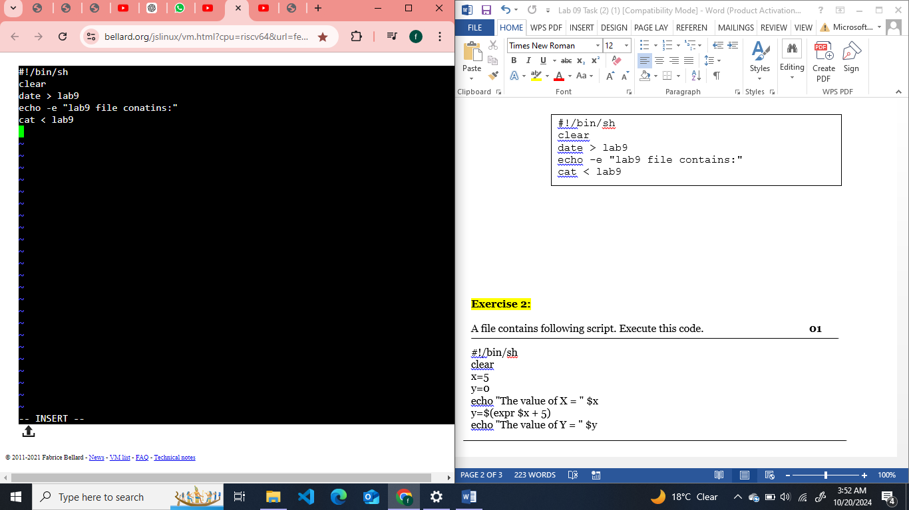

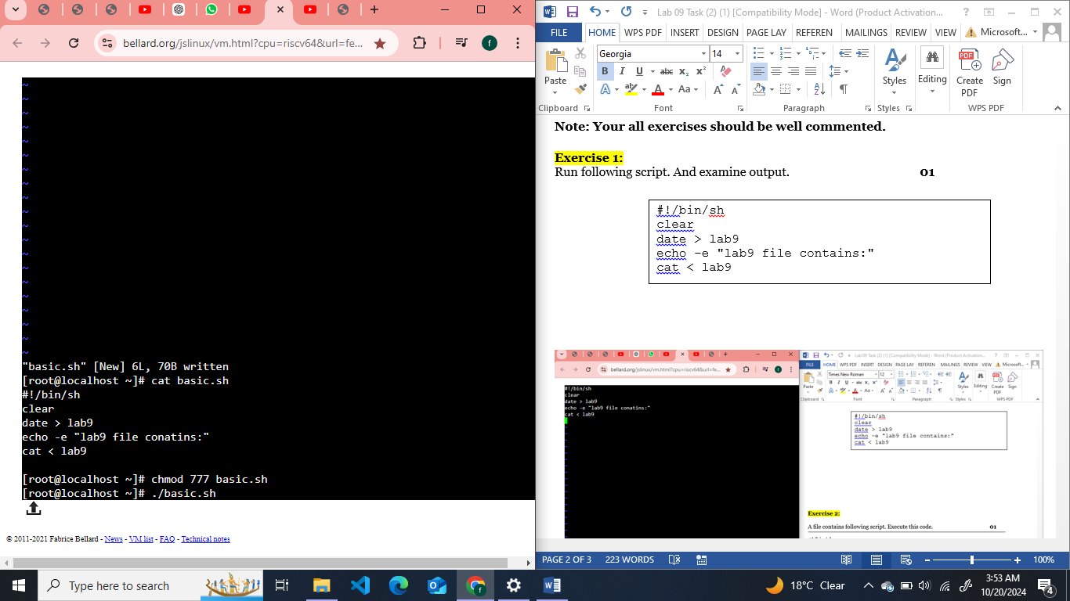

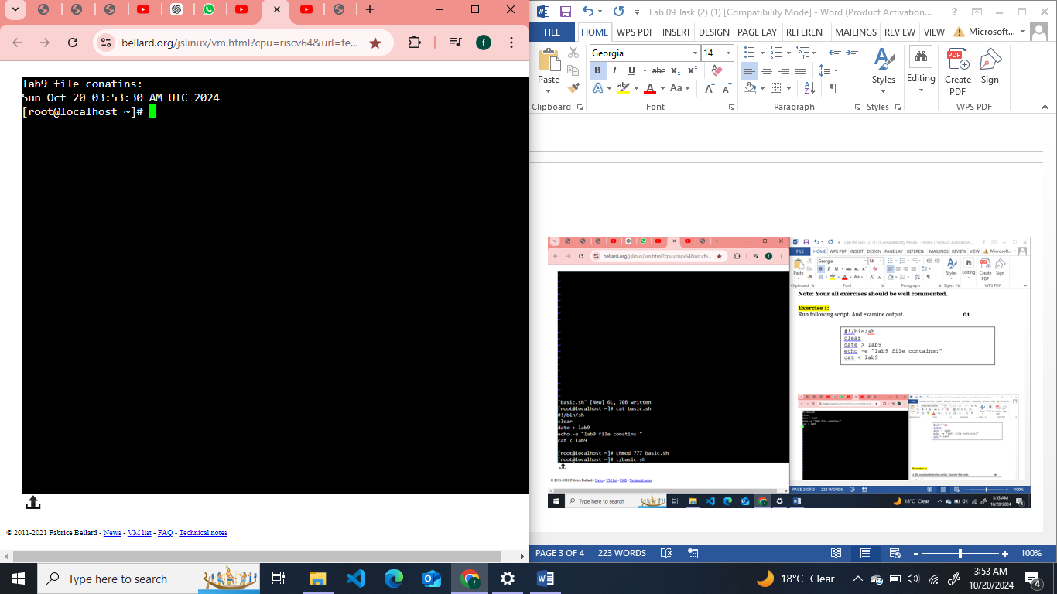

**Exercise 2:**

A file contains following script. Execute this code. **01**

#!/bin/sh

clear

x=5

y=0

echo "The value of X = " $x

y=$(expr $x + 5)

echo "The value of Y = " $y

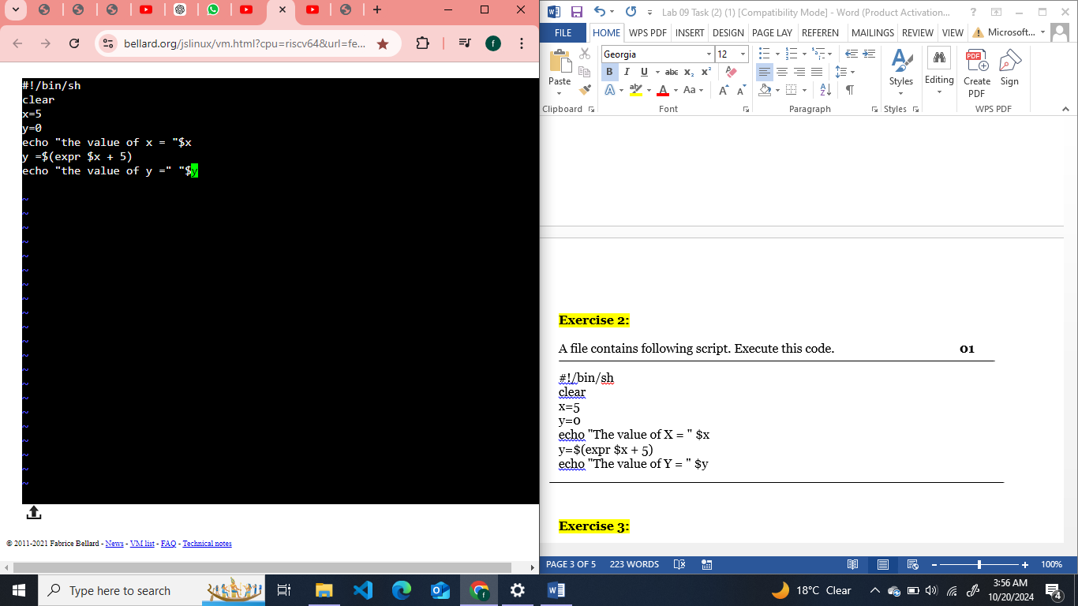

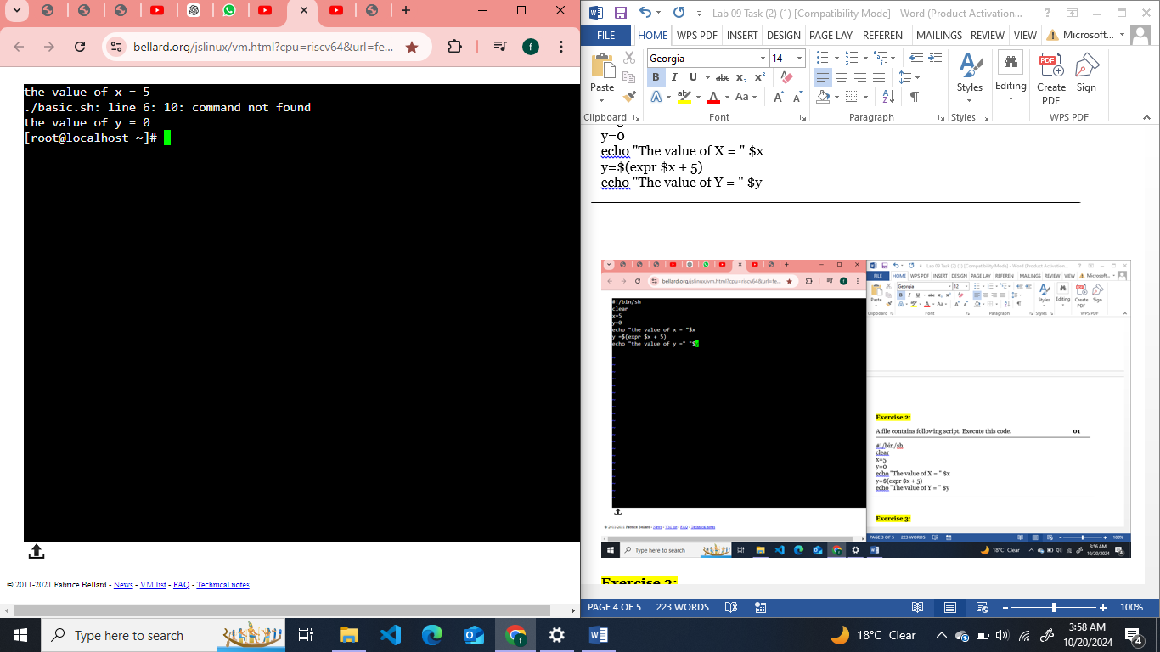

**Exercise 3:**

Write shell script that reads 2 integer values from user and print their sum on screen. **02**

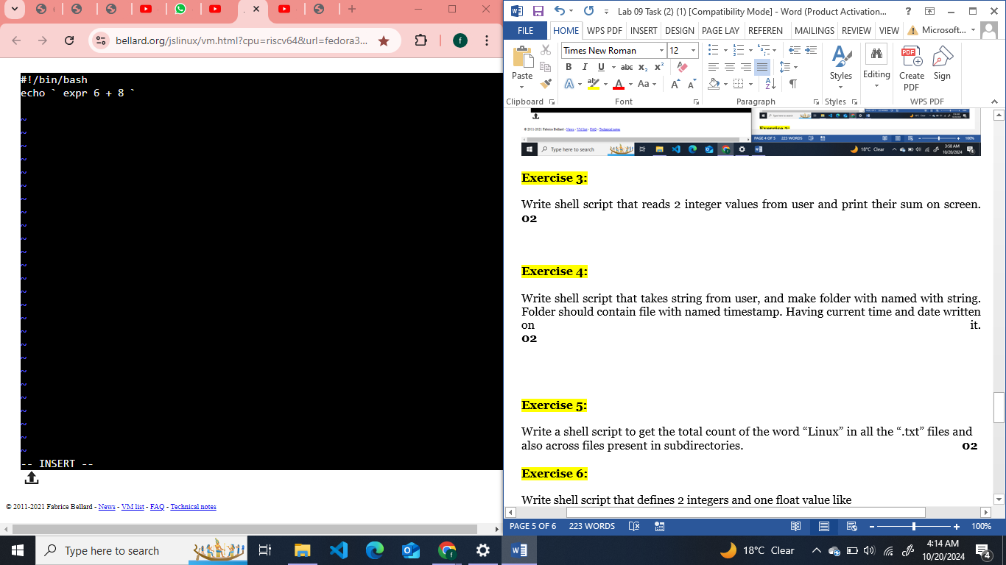

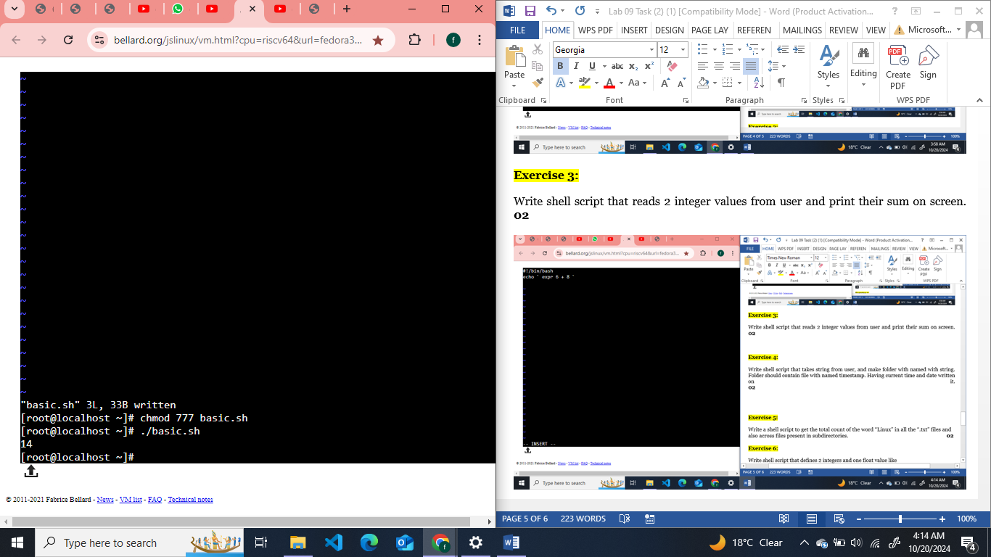

**Exercise 4:**

Write shell script that takes string from user, and make folder with named with string. Folder should contain file with named timestamp. Having current time and date written on it. **02**

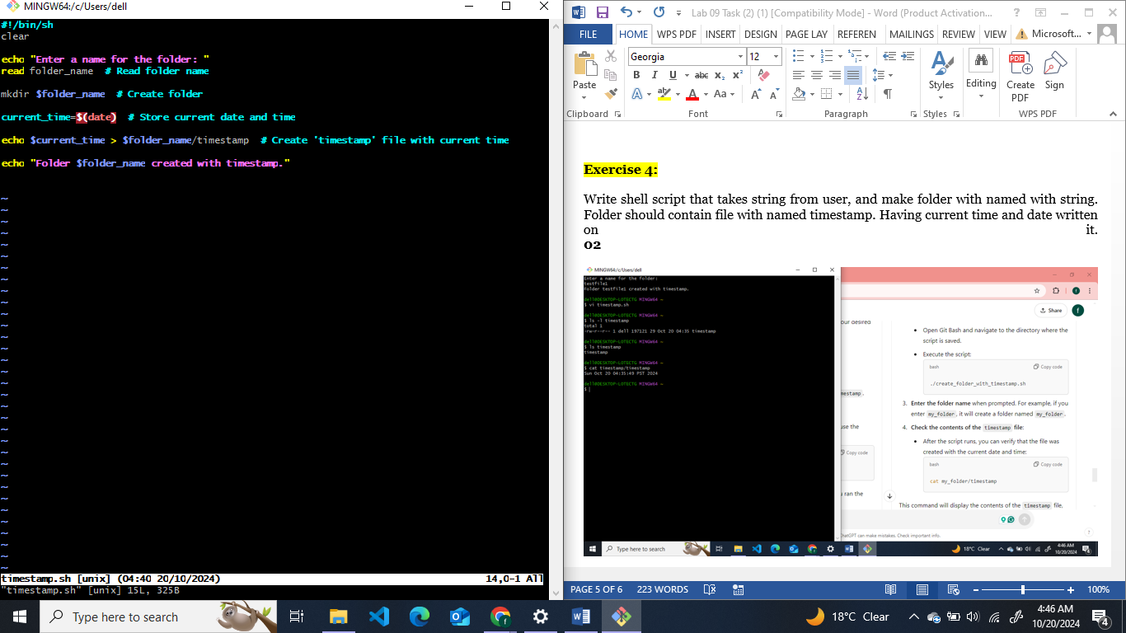

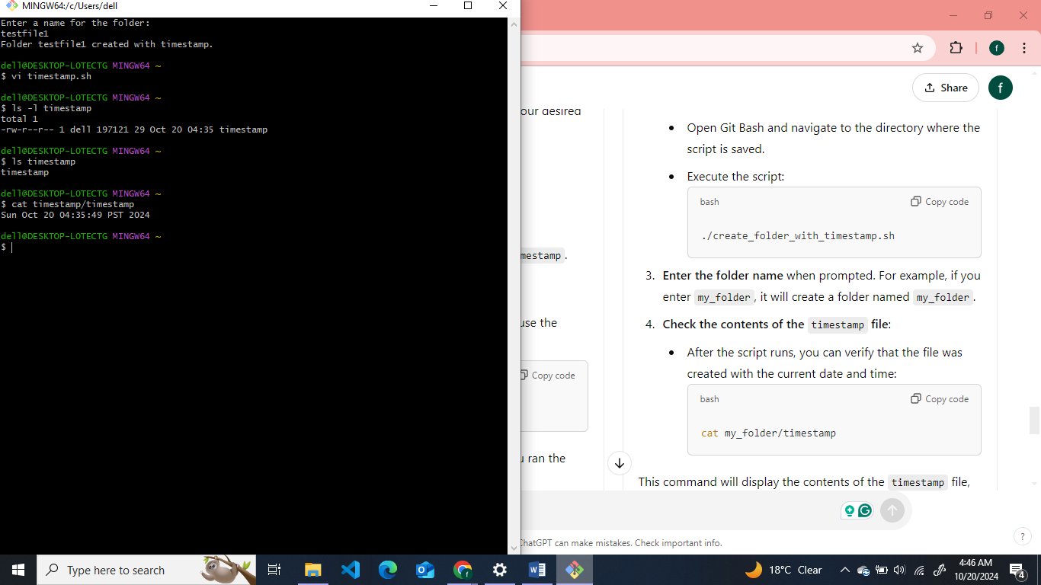

**Exercise 5:**

### Write a shell script to get the total count of the word “Linux” in all the “.txt” files and also across files present in subdirectories.

### 

### 

**Exercise 6:**

Write shell script that defines 2 integers and one float value like

a=5

b=7

c=5.5

Perform multiplication of integers then divide with float.

and finally print result with four decimal places. like 6.3636

you have to use pipe operator ( | ) to send variables to **bc** utility for arithmetic. **02**

**Total Marks: 10**